**W2 mini assignment**

Student ID: 490111165 Student name: Jialu He

**1. Identify 3 important tasks you want to be able to do when you read an e-textbook. Write each on a post-it-like note paper.**

--BGM. Add some music, such as light music or white noise, to help readers concentrated.

--Mini reading goal. Divide the whole book into several parts which is the reader’s goal. For example, Tom want to finish a novel in 7 days, so our e-book system can help him divided this book into 7 parts automatically. If he finished the plan for the day, the e-book system will ask him whether he needs a rest.

--Time reminder. People can set rest time. For example, readers can set reminders to rest every hour.

**2. The Time Reminder System for E-book**

The Time Reminder System provides many suggestive tips for controlling E-book reading time inside or outside of the app, which can help readers to master their reading process. It can relieve pressure of facing the whole book and improve satisfaction when readers finish daily goals.

When readers add a new e-book to their bookshelf, the Time Reminder System will ask how many days they want to finish, then divide the book into mini parts. Readers will finish on time if they follow their plan. If they forget to read one day, the system will remind them, using an external prompt message at a certain time. Besides, to avoid using eyes too much, this system can remind whether readers need a rest after a long time reading. All the setting can design into suggestion mode or freedom mode, which is already set some content according to surveys or which will be set by users themselves.

**3. What are the key claims of this paper and what is the evidence presented for these claims? (Claims, Evidence, Adherence rates, Important, Not important, Habituation, ESM)**

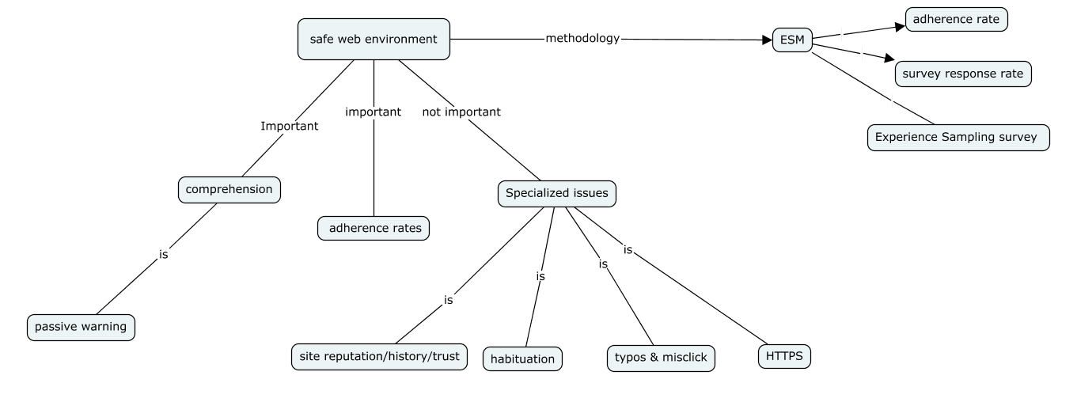

**4.**

**Two challenges:** comprehension & adherence rates –solving a range of smaller contextual misunderstandings

**Browsers warn:** malware & HTTP errors & social engineering network attacks & phishing

**Problems:** incomprehensible warning text & passive warning & habituation

**Telemetry studies limitation:** it could generate statistics about how users behave in the wild and why

**Specialized issues:** habituation; site reputation; had not seen before; HTTPS; typos&misclicks

**ESM(Experience Sampling Method):** ①how chrome & Firefox users make decisions about contemporary warning; ②let them take a range of factors into account when deciding whether to adhere to a warning – **focus questions:** ①why do users still not adhere to or comprehend warnings? ②when they adhere to warnings, why do they do?

**ESM variate:** browser; participant recruitment; compensation

**ESM participant do:** installed respective browser extensions & ran the extension & survey

**ESM research do:** developed an extension for each browser & collected by extensions

**Results: Adherence Rate:** ssl-noproceed; maleare-noproceed; phishing warning

**Survey Response Rate:** participants, number of survey responses, response rate(responses divided by prompts)

Factors: chrome—the lack of compensation for users

Firefox—low rate for users

**Experience Sampling Survey Result –** proceeding – site reputation, own judgement or knowledge, still want to do

Nonproceeding – preserving security or safety, trust, typos and misclick, other web site replacement

**Discussion:** habituation, comprehension, site reputation, typos and misclick , safe alternatives and discourage frivolous tasks, sample comparison

**5. usability** is the extent to which a system, product or service can be used by specified users to achieve specified goals with effectiveness, efficiency and satisfaction in a specified context of use. It means how easy and pleasant the features are to use. Usability should be learnability, efficiency, memorability, less errors and high satisfaction.

**Utility** is whether it provides the features you need. **Useful = usability + utility**

**Usability engineering** is building upon science and practitioner research and experience, using systematic ways to tackle the task of creating usable interfaces. It considers user experience as additional to usability

**Why it is hard to design usable interfaces? The main one** is that it is hard for designers to think like the users, especially when they have different background and experience when using a same product or system. In addition, the design of interface is also a problem that how to balance the utility and beauty, how to make it easy for people to use, how to deal with the complex function realization and it should be limited by IP issues.

**W2 mini assignment**

Student ID: 490111165 Student name: Jialu He

**1. The Time Reminder System for E-book**

The Time Reminder System provides many suggestive tips for controlling E-book reading time inside or outside of the app, which can help readers to master their reading process. It can relieve pressure of facing the whole book and improve satisfaction when readers finish daily goals.

When readers add a new e-book to their bookshelf, the Time Reminder System will ask how many days they want to finish, then divide the book into mini parts. Readers will finish on time if they follow their plan. If they forget to read one day, the system will remind them, using an external prompt message at a certain time. Besides, to avoid using eyes too much, this system can remind whether readers need a rest after a long time reading. All the setting can design into suggestion mode or freedom mode, which is already set some content according to surveys or which will be set by users themselves.

**2. What are the key claims of this paper and what is the evidence presented for these claims?**

